Feature selection results for exp_10_part_2 and Nmin = 10

1. result: (signal_strength, peak_frequency, amp_of_peak_frequency)
Estimated Epsilon: 0.019911, Picked Epsilon: 0.029911, MinNumPoints: 10
DBCV index value: 0.93686
cluster -1 had 3.8835% single peaks
cluster 1 had 95.1456% single peaks
cluster 2 had 0.48544% single peaks
cluster 3 had 0% single peaks
cluster 4 had 0.48544% single peaks
cluster 5 had 0% single peaks
cluster 6 had 0% single peaks
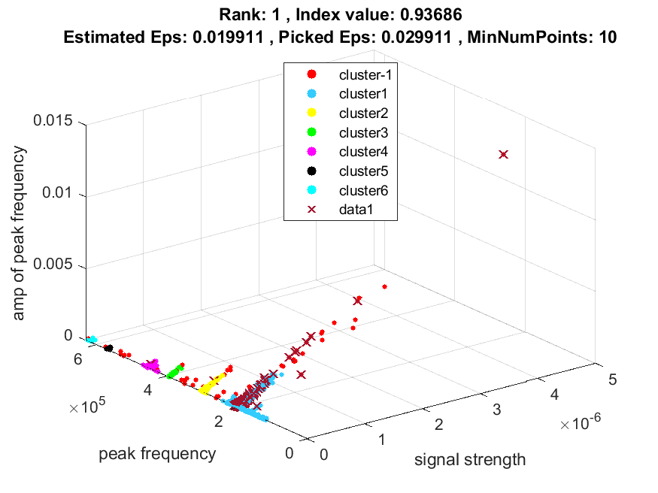
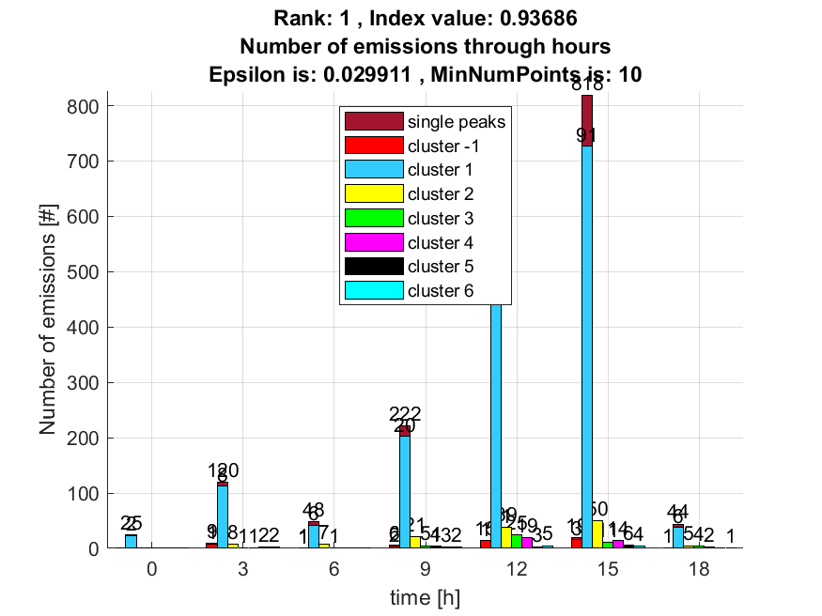

2. result: (peak_amplitude, peak_frequency, amp_of_peak_frequency)
Estimated Epsilon: 0.026244, Picked Epsilon: 0.036244, MinNumPoints: 10
DBCV index value: 0.92565
cluster -1 had 4.3689% single peaks
cluster 1 had 94.6602% single peaks
cluster 2 had 0.48544% single peaks
cluster 3 had 0% single peaks
cluster 4 had 0.48544% single peaks
cluster 5 had 0% single peaks
cluster 6 had 0% single peaks
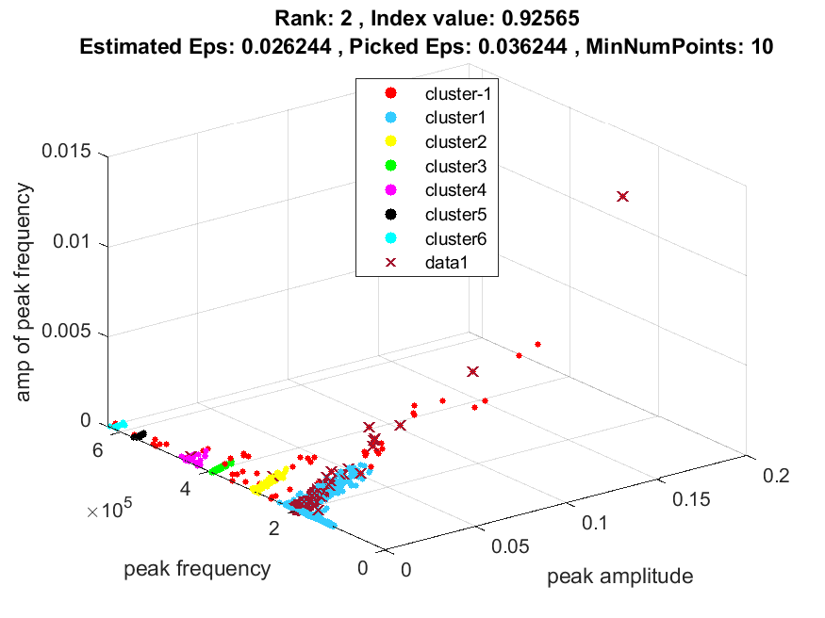
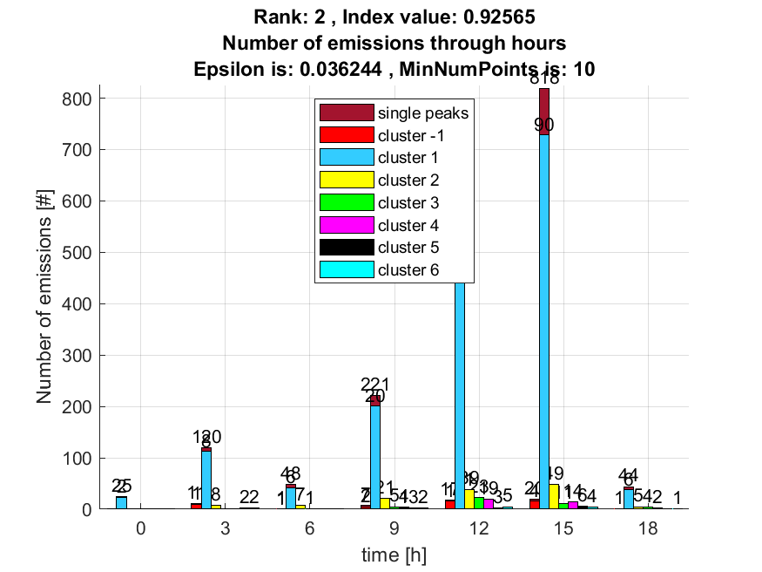

3. result: (rise_time, peak_frequency, total_counts)
Estimated Epsilon: 0.057657, Picked Epsilon: 0.067657, MinNumPoints: 10
DBCV index value: 0.89431
cluster -1 had 1.9417% single peaks
cluster 1 had 97.0874% single peaks
cluster 2 had 0.48544% single peaks
cluster 3 had 0.48544% single peaks
cluster 4 had 0% single peaks
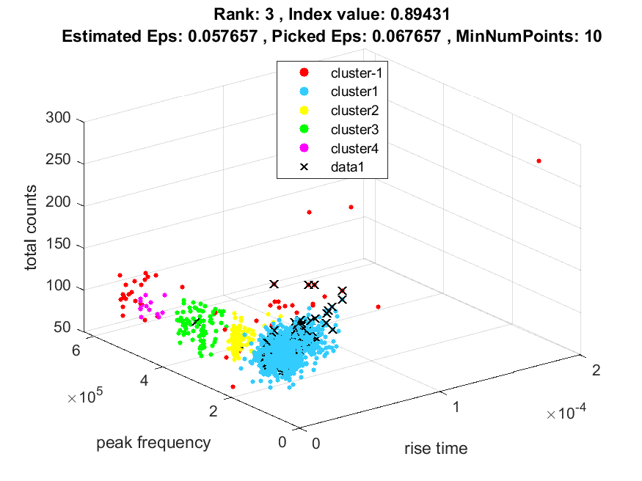
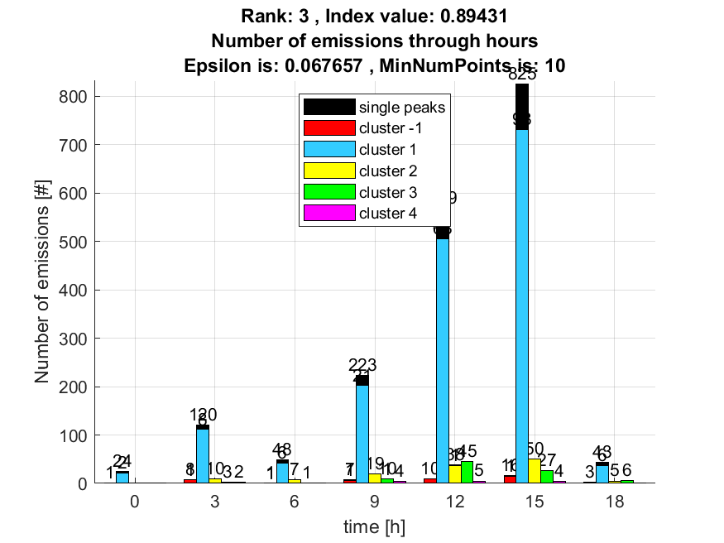

4. result: (rise_time, peak_frequency, amp_of_peak_frequency)
Estimated Epsilon: 0.028289, Picked Epsilon: 0.038289, MinNumPoints: 10
DBCV index value: 0.89417
cluster -1 had 5.8252% single peaks
cluster 1 had 93.2039% single peaks
cluster 2 had 0.48544% single peaks
cluster 3 had 0% single peaks
cluster 4 had 0.48544% single peaks
cluster 5 had 0% single peaks
cluster 6 had 0% single peaks
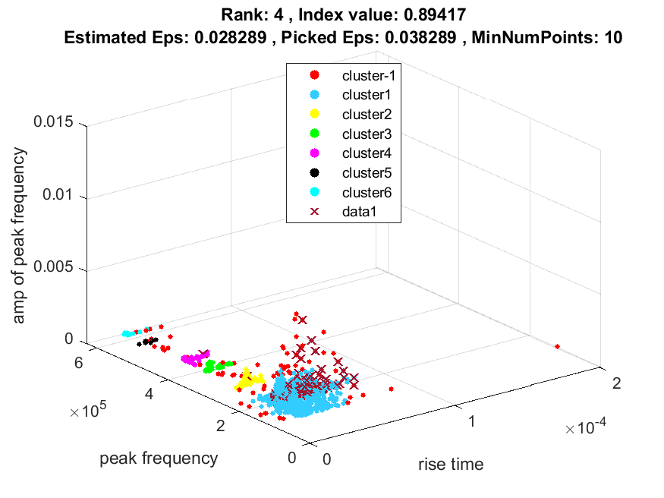
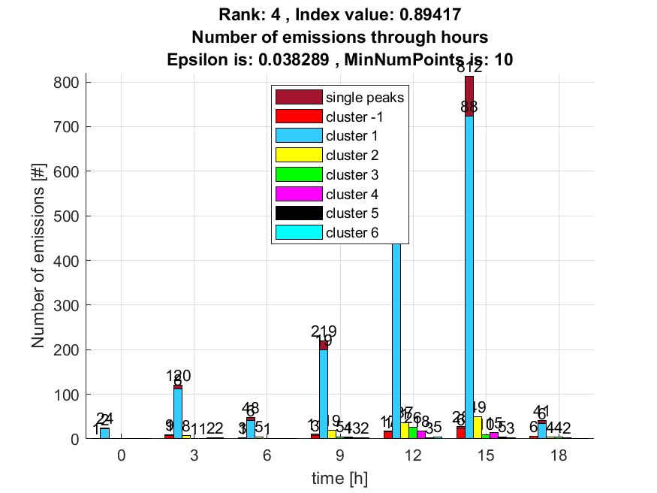

5. result: (pp1, peak_frequency, fall_time)
Estimated Epsilon: 0.052532, Picked Epsilon: 0.062532, MinNumPoints: 10
DBCV index value: 0.87359
cluster -1 had 0.48544% single peaks
cluster 1 had 98.5437% single peaks
cluster 2 had 0.48544% single peaks
cluster 3 had 0.48544% single peaks
cluster 4 had 0% single peaks
cluster 5 had 0% single peaks
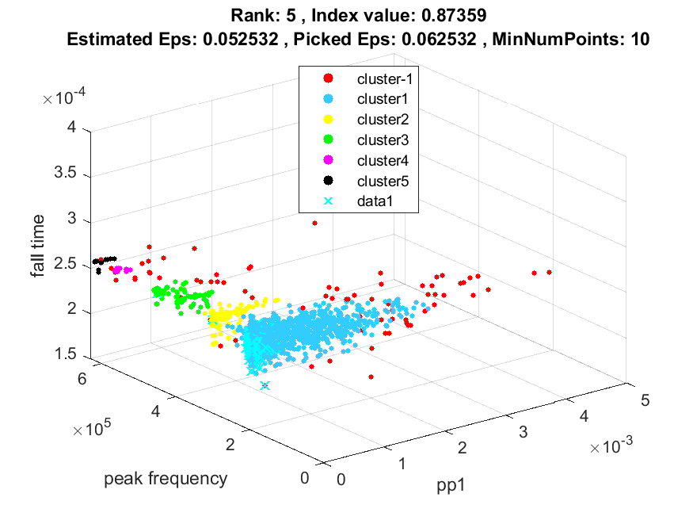
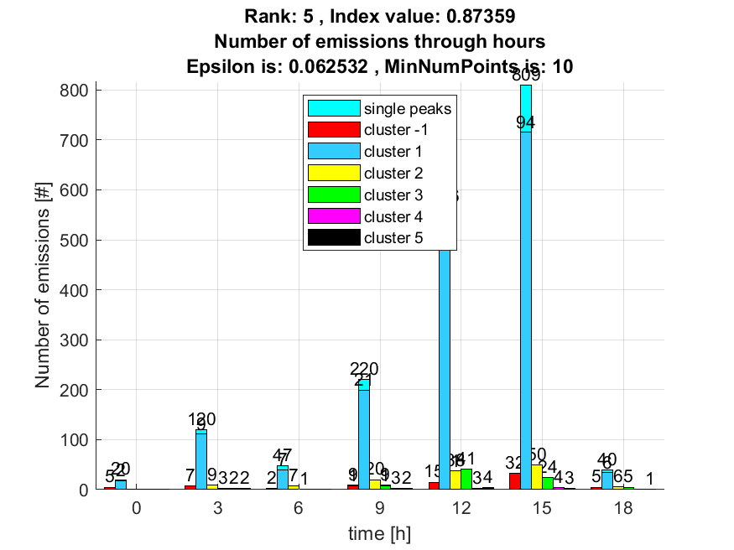

6. result: (signal_strength, pp1, peak_frequency)
Estimated Epsilon: 0.031224, Picked Epsilon: 0.041224, MinNumPoints: 10
DBCV index value: 0.87041
cluster -1 had 2.4272% single peaks
cluster 1 had 96.6019% single peaks
cluster 2 had 0.48544% single peaks
cluster 3 had 0% single peaks
cluster 4 had 0.48544% single peaks
cluster 5 had 0% single peaks
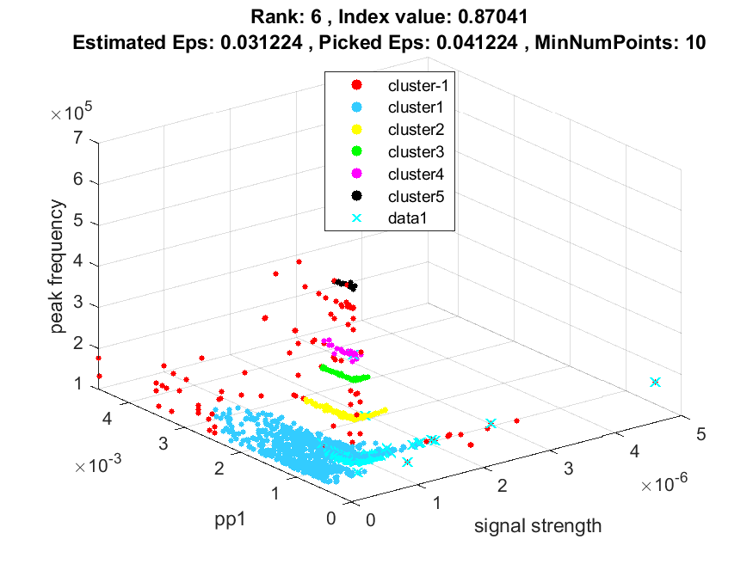
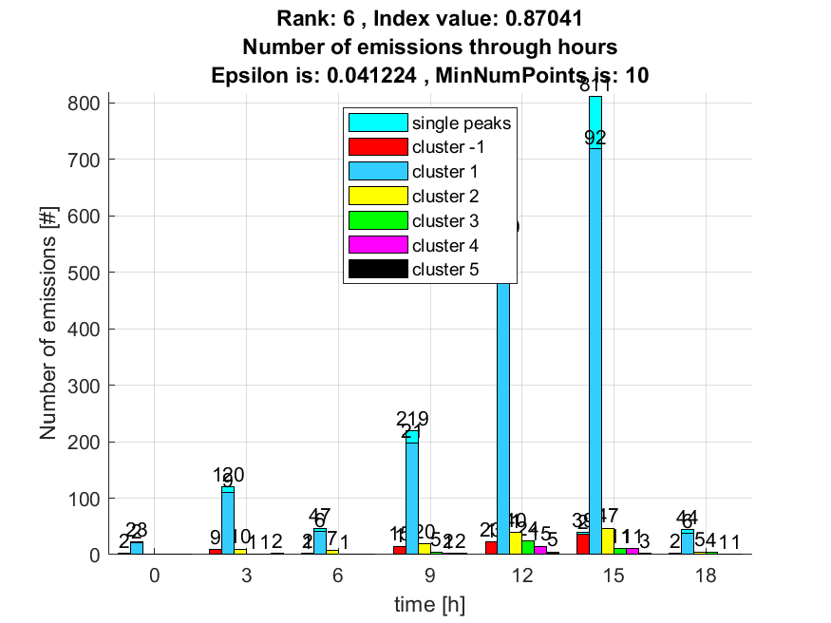

7. result: (peak_frequency, amp_of_peak_frequency, total_counts)
Estimated Epsilon: 0.038793, Picked Epsilon: 0.048793, MinNumPoints: 10
DBCV index value: 0.86909
cluster -1 had 6.7961% single peaks
cluster 1 had 92.233% single peaks
cluster 2 had 0.48544% single peaks
cluster 3 had 0% single peaks
cluster 4 had 0.48544% single peaks
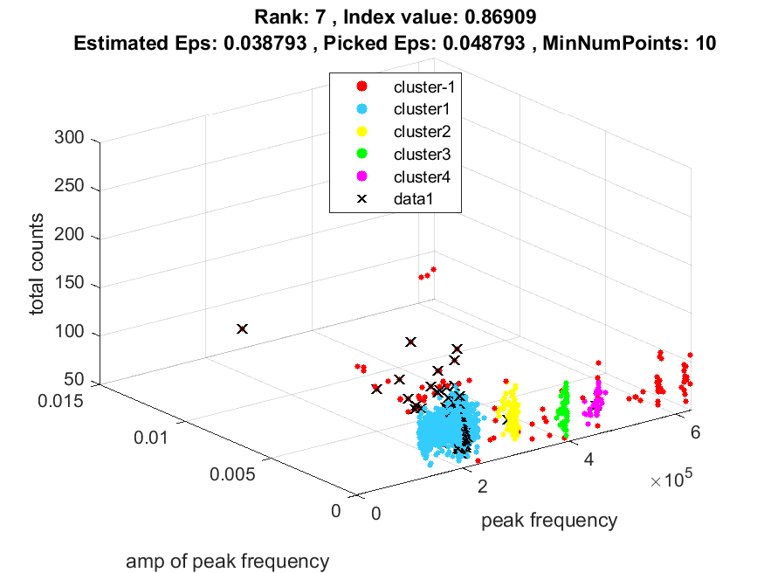
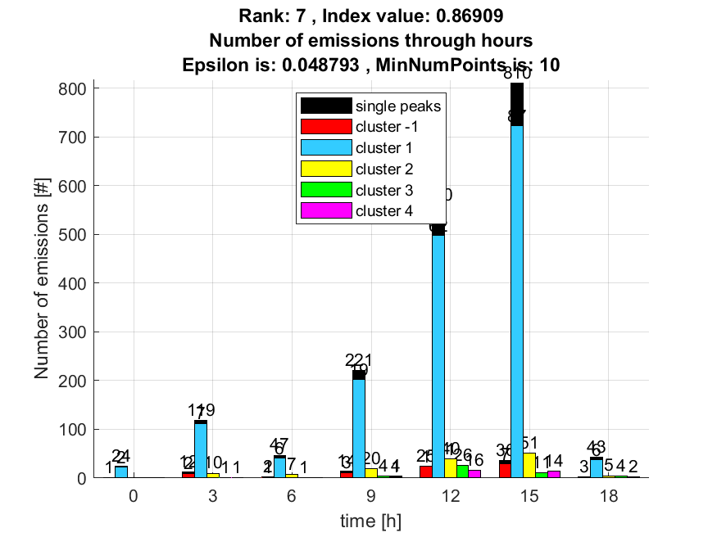

8. result: (pp1, peak_frequency, amp_of_peak_frequency)
Estimated Epsilon: 0.029232, Picked Epsilon: 0.039232, MinNumPoints: 10
DBCV index value: 0.86737
cluster -1 had 2.4272% single peaks
cluster 1 had 96.6019% single peaks
cluster 2 had 0.48544% single peaks
cluster 3 had 0% single peaks
cluster 4 had 0.48544% single peaks
cluster 5 had 0% single peaks
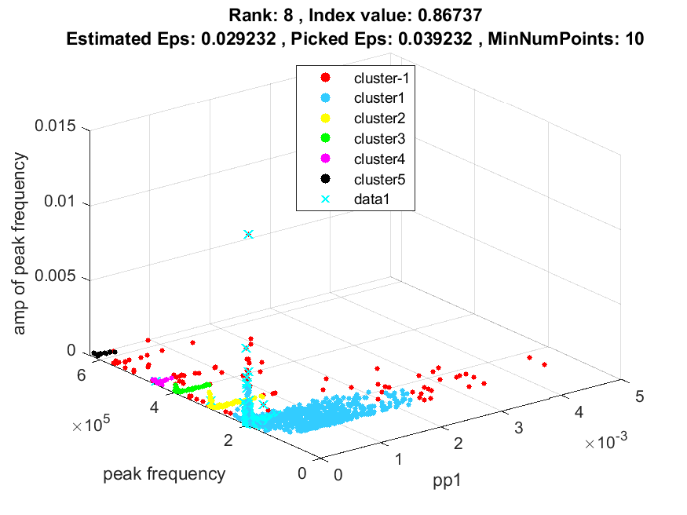
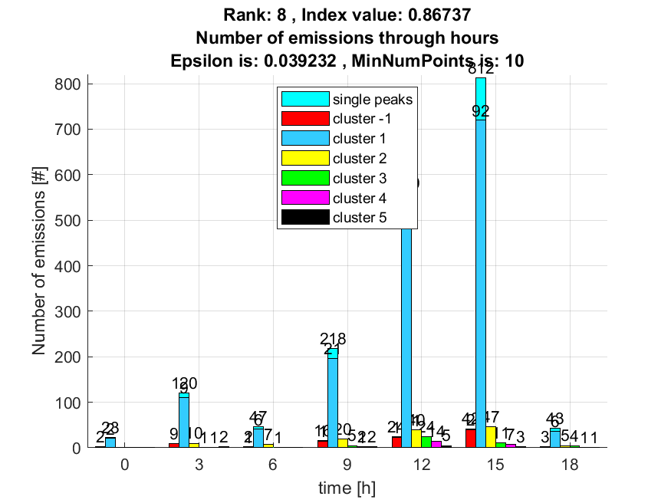

9. result: (peak_amplitude, pp1, peak_frequency)
Estimated Epsilon: 0.029273, Picked Epsilon: 0.039273, MinNumPoints: 10
DBCV index value: 0.86131
cluster -1 had 1.9417% single peaks
cluster 1 had 97.0874% single peaks
cluster 2 had 0.48544% single peaks
cluster 3 had 0% single peaks
cluster 4 had 0.48544% single peaks
cluster 5 had 0% single peaks
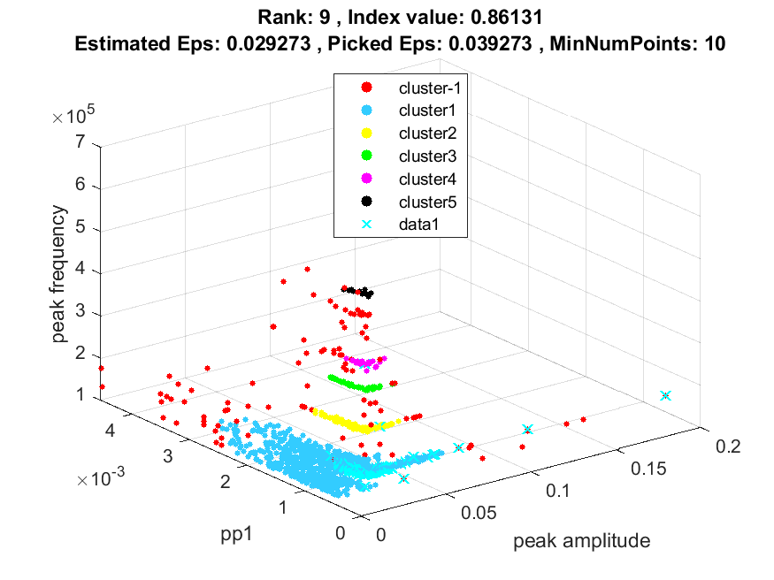
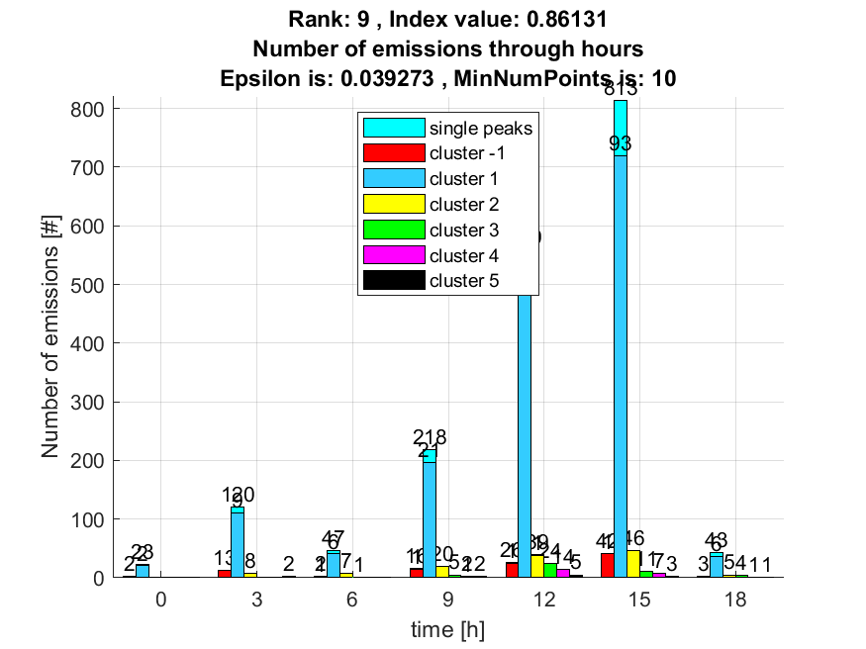

10. result: (peak_amplitude, peak_frequency, total_counts)
Estimated Epsilon: 0.035722, Picked Epsilon: 0.045722, MinNumPoints: 10
DBCV index value: 0.84912
cluster -1 had 4.3689% single peaks
cluster 1 had 94.6602% single peaks
cluster 2 had 0.48544% single peaks
cluster 3 had 0% single peaks
cluster 4 had 0.48544% single peaks
